**Task/time tracker dashboard project.**

**Overview**

**Each organization needs to check work time and workload of employees. Sometimes it more preferable to look on visual interpretation. In century of data and many attributes of work process top-management and even chiefs of departments need to be involved in time management. And such visualization helps in this.**

**Object:** The project to check current users, teams, projects, tasks and time for dealing with.. All user can see in good visualization form all information. Users, who are involved into making decisions can make it better and faster. Created opportunity of implementation dashboards in different systems, they has being done for different platforms. Dashboards has been realized on 3 different platform – QlikView, Qlik Sense and SSRS.

Main part of creating data and visualization has being developed on side MS SQL Server and QlikView, Qlik Sense and SSRS.

MS SQL script to build data and stored procedures as a [source](https://github.com/VengiU/TMS-Visualization/blob/master/SQL_Query_for%20create%20base.sql)

Dashboards: QlikView – [source](https://github.com/VengiU/TMS-Visualization/blob/master/QlikView%20Time%20managm%20sys%20DASHBORDS.qvw)

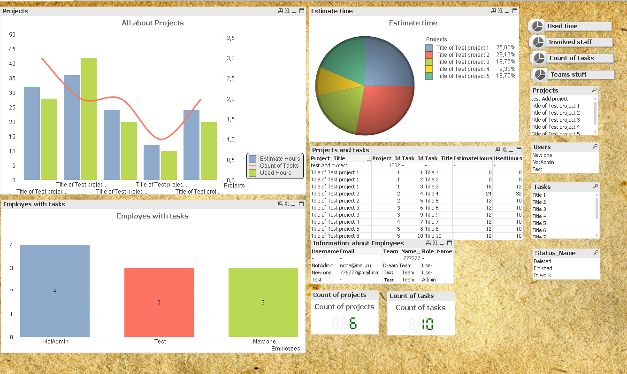

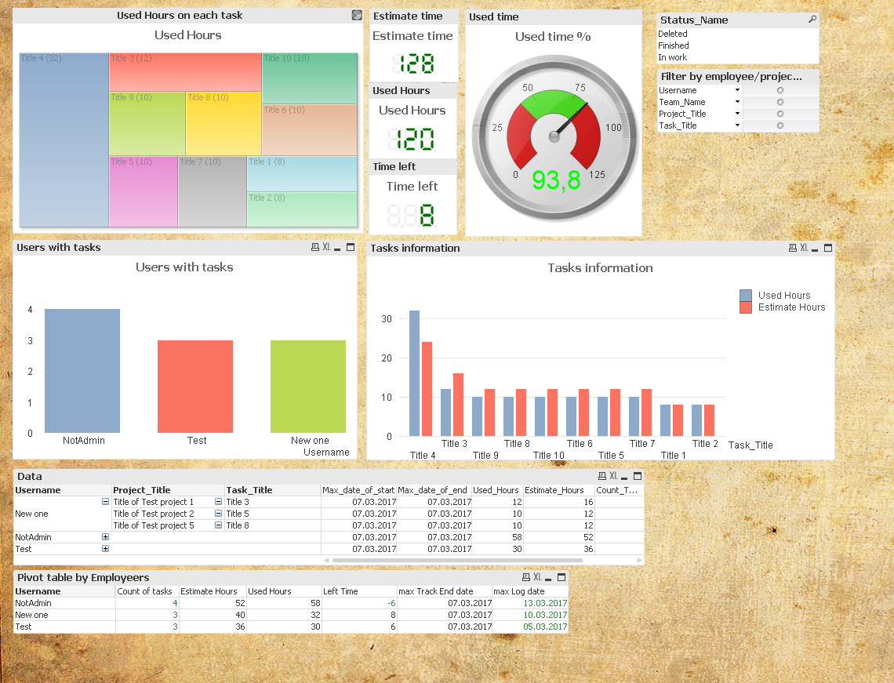

Qlik Sense – [source](https://github.com/VengiU/TMS-Visualization/blob/master/Qlik%20Sense%20Time%20managm%20sys%20DASHBORDS.qvf)

On cloud: <https://eu.qlikcloud.com/view/58c8024422b279000156c29e>

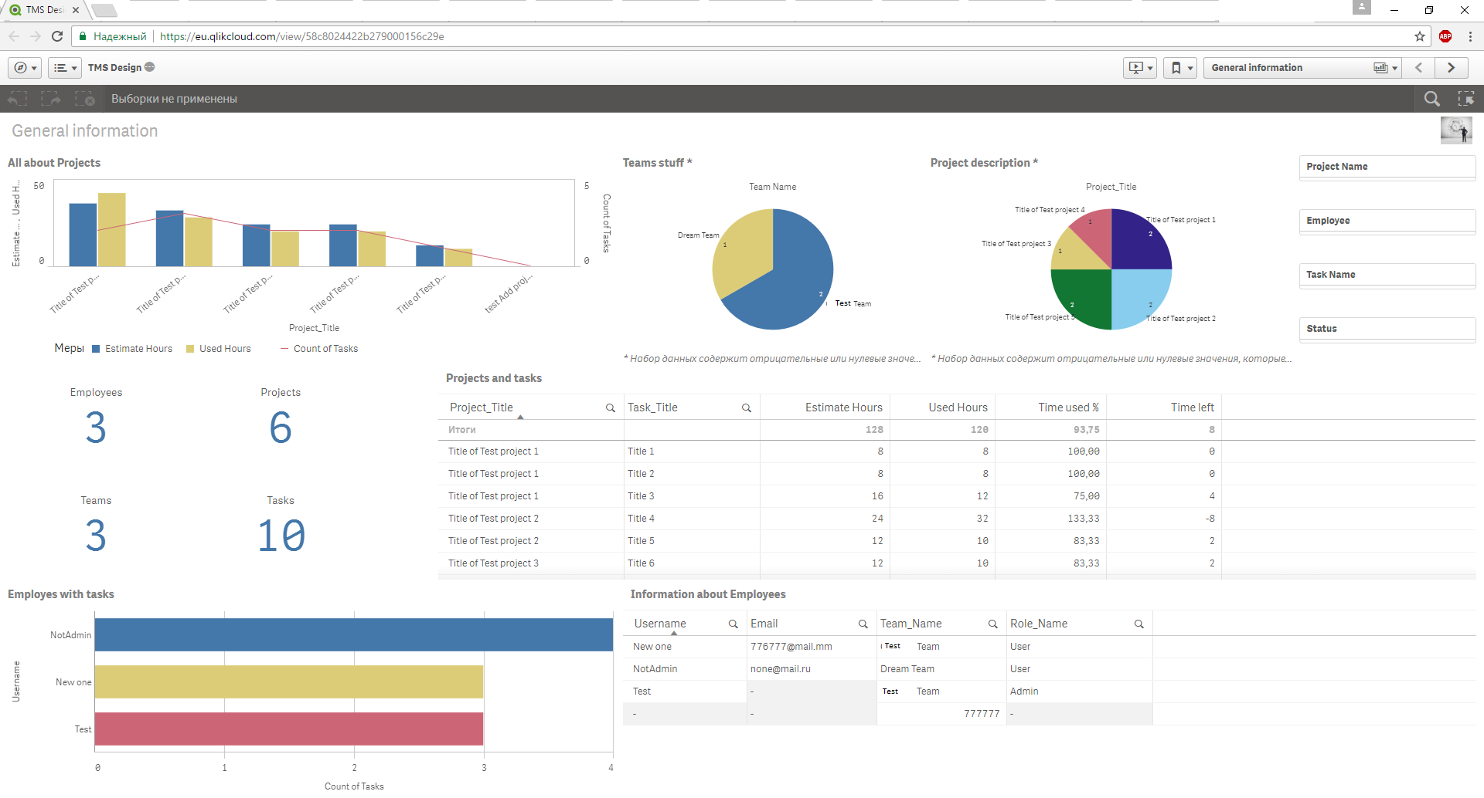

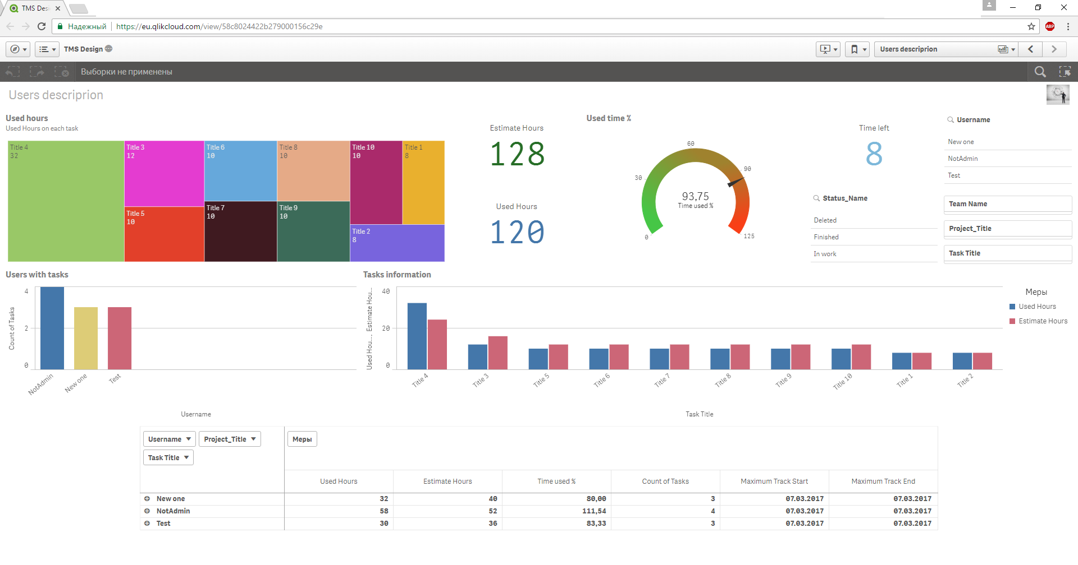

SSRS – [source](https://github.com/VengiU/TMS-Visualization/blob/master/SSRS%20Time%20managm%20sys%20DASHBORDS.rar)

